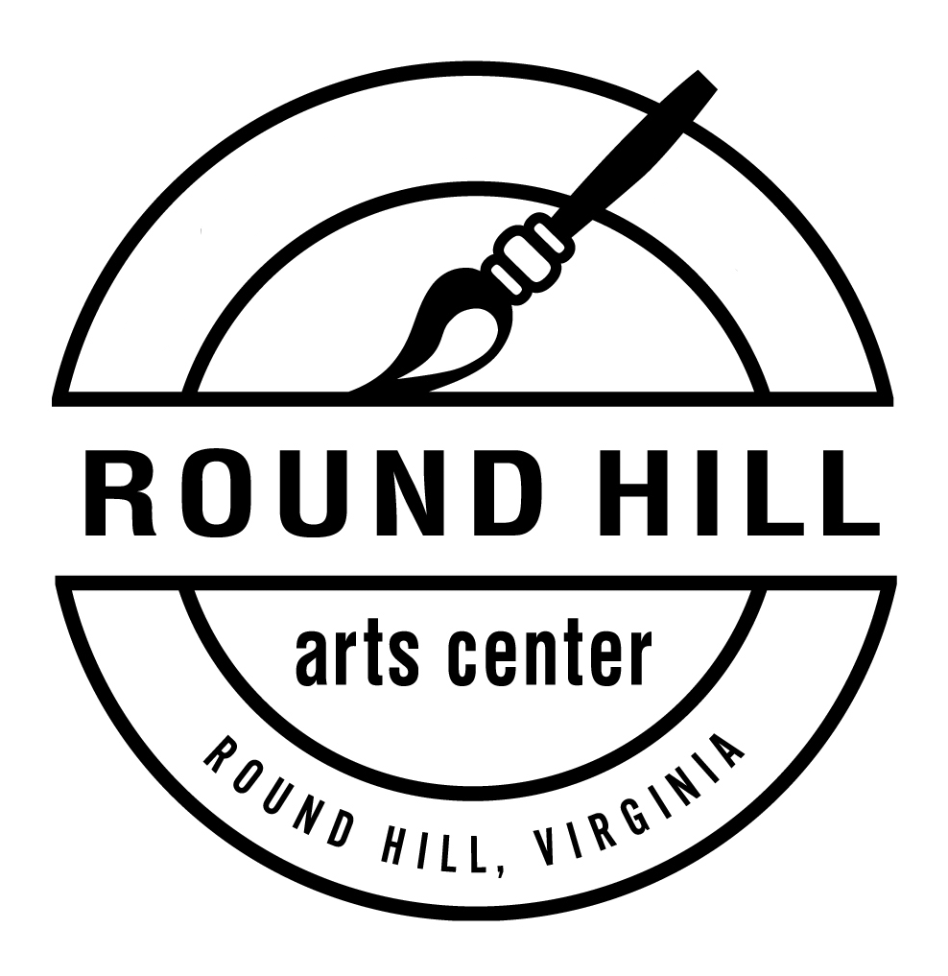
Round Hill Arts Center
35246 Harry Byrd Highway, Suite 170
Round Hill, VA 20142

Round Hill Arts Center Instructor Agreement

Instructor Name:
Address:
Phone: Email:
Emergency Contact:

Thank you for you for offering a class through the Round Hill Arts Center. Please read these guidelines carefully. RHAC offers classes as part of our goal to educate and promote community involvement in the arts. We look for quality instructors accomplished in their field and dedicated to sharing their skills, knowledge, and expertise. Our Manager will contact you to discuss your proposal, confirm dates and clarify the terms of each specific class offering.

- Instructors are hired as independent contractors. As a contractor, the instructor agrees that he/she is not an employee of the Round Hill Arts Center, nor is he/she entitled to employee benefits such as sick leave and vacation. No deductions, withholding for any taxes, FICA contributions, unemployment, or any other employee benefits or burdens will be made by RHAC on behalf of the contractor.

- RHAC will work with the instructor to establish class fees and determine the minimum and maximum number of students for the class. RHAC will supply classroom space, online registration, and fee collection for classes and workshops.

- Both RHAC and instructors will work to promote and fill classes. If a class does not have the minimum students required prior to the starting date it may be cancelled. RHAC will notify students and return payments. RHAC reserves the right to cancel a class before it begins without obligation to pay the instructor.

- An instructor may not cancel or make changes in the meeting dates or times of a class without prior consultation with the RHAC Manager. If an instructor is ill or unable to meet with his/her class in an emergency situation, the instructor must notify the Manager as soon as possible. It is the instructor’s responsibility to notify students of a class cancellation of this nature. Classes missed by the instructor must be rescheduled to accommodate the maximum number of students possible.

- RHAC will notify students and instructor in case of a class change or cancellation made by the Arts Center. In the event of inclement weather, RHAC follows Loudoun County Public Schools closings and delays, but exceptions maybe made on a case by case basis depending on weather and road conditions.

- If a material fee is determined in the course proposal process, it will be included in the class fee. The instructor is responsible for purchasing and providing supplies listed on the course proposal form unless other arrangements are made in advance.

- RHAC will reimburse instructors for all materials purchased for the class that were listed and approved in the course proposal process. There is no reimbursement by RHAC to instructors who choose to provide additional items/supplies/tools/equipment for class or students which are not originally included on the itemized materials list. An invoice for materials reimbursement with original receipts is required when applicable.

- The instructor is responsible for providing all copies of handouts, maps, lists, etc. that are required for class, unless other arrangements are made.

- Instructors should arrive in ample time to arrange the room to their specifications for the greatest comfort and ease of the participants. Instructors must clean and return classroom space to its original state after each class meeting or workshop.

- Instructors must be helpful, positive, and courteous at all times. RHAC does not condone inappropriate, negative, or offensive behavior by or towards instructors, participants, and staff. If an instructor, participant, or guest engages in an inappropriate or unsafe manner, he or she will be asked to leave the premises.

- It is the instructor’s responsibility to know where the first aid kit is located. For minor first aid (band-aids, etc.) the first aid kit will suffice. For serious accidents, DO NOT MOVE the injured participant, and call 9-1-1.

- The instructor agrees all photographs (with signed release from participants) of the workshop are property of RHAC and may be used for promotion.

- RHAC will pay the instructor by check on the first of each month for the previous month’s workshops unless the RHAC and the instructor arrange a separate agreement.

- The instructor agrees to hold RHAC and any affiliates thereof, harmless in relationship to any liabilities which may arise from the workshop, performance, or class while on, in, or around the property from the instructor, heirs, or from any other forces. Should unforeseen circumstances arise from either party that requires rescheduling or cancellation of the workshop; both parties agree to hold each other harmless.

As a contracted instructor with the Round Hill Arts Center, I agree to all of the above stipulations and requirements. I realize negligence or disregard of the above agreements may result in discontinuing of my classes and withholding of payment by Round Hill Arts Center.
_________________________________ ________________________________
signature date
Class/Workshop: _______________________________________________________________________________
(list general titles, such as pottery, painting, etc. if you teach more than 1 class)

